Experiment:
CONVERTING GRAVITATIONAL POTENTIAL ENERGY (GPE) TO KINETIC ENERGY (KE)

Method:
Equipment

- 1 x plastic tubing
- 1 x large marble
- 1 x stopwatch
- 2 x metre rulers
- 1 x electronic balance

Procedure
PART A
- Collect the Marble and set of electronic scales from the trolley.
- Weigh the marble. Record this mass in grams in column 3 of table 1, AND in column four as kilograms (divide by 1000). Because the mass of the marble does not change write these numbers all the way down column 3 and column 4.
- Calculate the GPE of the marble in table one.
- Show your teacher these calculations, get the okay to do the rest of the experiment.
PART B
Figure 1: 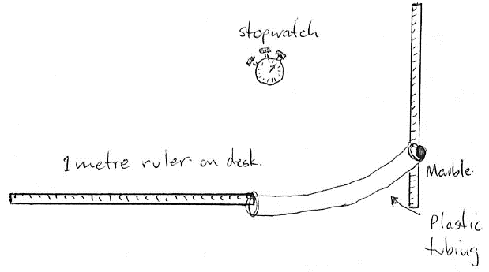

- Collect and assemble the equipment as shown in figure 1.
- Hold the plastic tubing (bottom edge) at 10 cm off the desk.
- When the marble is released it will come out at the bottom of the plastic tubing. Time how long the marble takes to cover one metre.
- Repeat this several times until you are reasonably sure your time is accurate. Record the time in column four of table 3.
- Repeat steps 6 to 8 but increase the height each time to 15 cm, 20cm, 25cm, and 30 cm.
- Return the equipment
- Calculate the velocity of the ball in column 4 of table 2
- Calculate the KE of the ball in column 5 of table 2.

RESULTS
TABLE 1: Calculating the Gravitational Potential energy of the marble.

Height at which marble is released  (cm) | Height at which marble is released  (metres) | Mass of the marble in grams  (g) | Mass of the marble in kilograms  (kilograms) | Gravitational Potential Energy – E_{GP} of the Marble  (Joules)  $$GPE=mass x 10 x height$$
10 | 0.2
15 | 0.25
20 | 0.30
25 | 0.35
30 | 0.40
TABLE 2: Measuring and Calculating the Kinetic Energy of the marble.

Height at which marble is released  (m) | Distance  the ball travelled at the bottom of the slope  (metres) | Time  taken for ball to travel this distance  (seconds) | Velocity  of the ball at the bottom of the slope  (metres/sec)  $$v=distance ÷time$$ | KINETIC ENERGY – E_{K} of the ball at the bottom of the slope  (joules)  $$KE= \frac{1}{2} x mass x {velocity}^{2}$$
0.2 | 1.0
0.25 | 1.0
0.30 | 1.0
0.35 | 1.0
0.40 | 1.0

What is happening?
The marble has a certain amount of Gravitational Potential Energy - GPE depending on the height from which it is released. This is the GPE you calculated in table one. When the marble is released the GPE is converted into “moving energy”, called Kinetic Energy – KE, and the marble moves faster the further it falls. By making the marble “fall” through a plastic tube we have converted its vertical “fall” into horizontal movement which is easier to measure. In theory the GPE the ball has before it is released should be equal to the KE of the ball when it rolls across the desk. The E_{K} is what we measured and calculated in table two.

Questions:

- When the ball was dropped from a higher height did it move at a greater velocity when it came out the bottom of the tube?

______________________________________________________________________________

- Compare the GPE in column 5 of table 1 to the KE of column 5 in table 2. Do the values for GPE match up with the values for KE? Describe the pattern you see.
__________________________________________________________________________________________________________________________________________________________________________________________________________________________________________

- What would have caused the differences between the GPE and the KE values? Explain your answer.

__________________________________________________________________________________________________________________________________________________________________________________________________________________________________________

